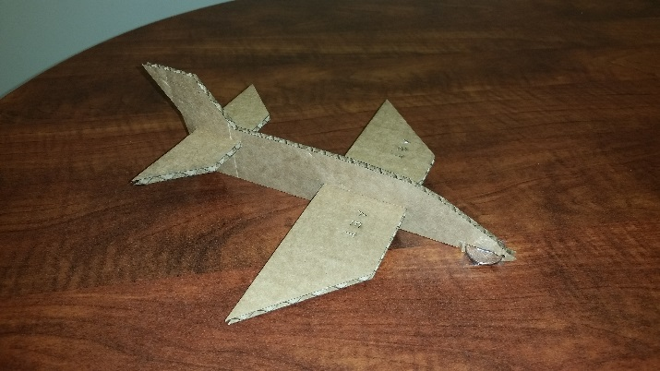
This three-piece “Penny Plane” glider made from cardboard is designed for long smooth glides. Remove the penny and it can be customized for acrobatic stunts. Laser cut flaps into the wings and tail-fins for greater control.

Project Guidelines:
- Capable of flying long, smooth glides
- Have the ability to maintain a straight flight path
- Should be assembled from 3 pieces without need for glue of adhesives
- Should contain some lettering
- Fuselage length 9”
- Workspace dimensions 10”x6”

Learning Outcomes: Understand measurement functions of CorelDraw, tolerances of the laser, form, fit and functional design, Apply DOE standards

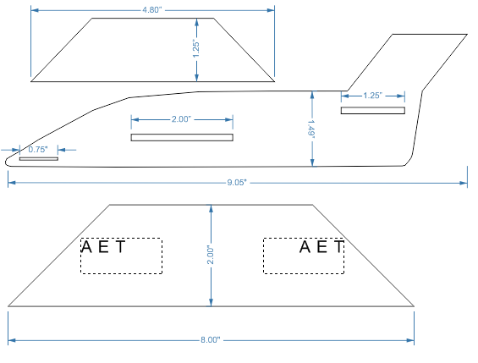
- Go to File, New, Create a New Document; name new project and enter dimensions of workspace
- Select basic shapes
- In menu click Object, Convert to curves
- Double click shape to Add Nodes
- Select line, Add Nodes, manipulate add more or less to get desired shape
- Determine size of wing and tail fin; follow steps 2-5
- Create through-holes
- Determine vector and raster cuts
- Save project

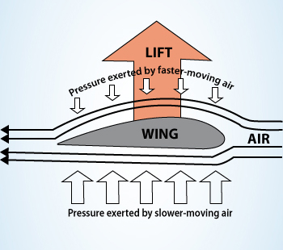
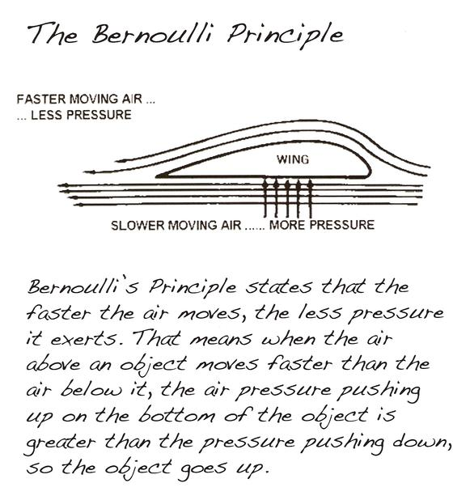

HS-ETS3-6(MA)
Use informational text to illustrate how a vehicle or device can be modified to produce a change in lift, drag, friction, thrust, and weight.

Examples of vehicles can include cars, boats, airplanes, and rockets. Considerations of lift require consideration of Bernoulli's principle

