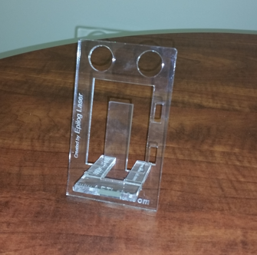
This two-piece cell phone stand project fabricated from acrylic can be positioned horizontal or vertical to fit most devices. A custom text can be engraved along the outer edge.

Project Specifications:
- Capable of supporting a cell phone
- Have the ability to hold the phone in both vertical and horizontal positions
- Should be assembled from at least 2 pieces without need for glue of adhesives
- Should contain some lettering
- Dimensions of stand should be 5”x3”.

Learning Outcomes: Understand measurement functions of CorelDraw, tolerances of the laser, form, fit and functional design, Apply DOE standards
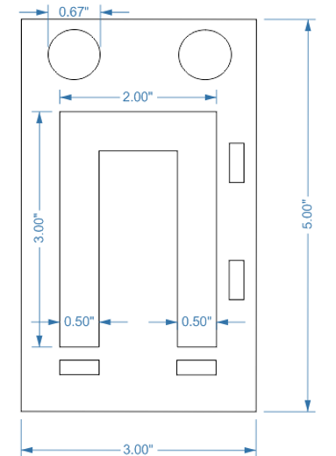
- Go to File, New, Create a New Document; name new project and enter dimensions of workspace
- Select Rectangle Tool - Create 2nd and 3rd rectangle; snap to object, center and align on edge
- Measure using dimension tool
- Use virtual segment delete tool to remove segment
- Create through holes; determine material thickness
- Group together
- Use copy and rotate for through holes to place perpendicular to
- Create circle and mirror – windows, dockers, transformation, scale and mirror
- Determine vector cuts
- Save Project

8.MS-ETS2-5(MA). Present information that illustrates how a product can be created using basic processes in manufacturing systems, including forming, separating, conditioning, assembling, finishing, quality control, and safety.

HS-ETS2-1(MA). Determine the best application of manufacturing processes to create parts of desired shape, size, and finish based on available resources and safety.

Clarification Statement:
Examples of processes can include forming (molding of plastics, casting of metals, shaping, rolling, forging, and stamping), machining (cutting and milling), conditioning (thermal, mechanical, and chemical processes), and finishing.
